WEB TECHNOLOGIES

JAVASCRIPT WEB APPS



Oleh :

Wayan Restu Cahyana/2215101035

IKI Class

UNIVERSITAS PENDIDIKAN GANESHA

2023

# **DAFTAR ISI**

DAFTAR ISI i

CHAPTER I 1

INTRODUCTION 1

A. Basic Theory 1

B. Purpose 1

1. To find out the results of responsive web design. 1

2. To fulfill the assignment for the Web Technology course. 1

CHAPTER II 2

DISCUSSION 2

A. Initial Web View 2

B. Fibonacci Web View 2

C. Compute Volume Web View 3

D. To-Do List Web View 3

E. Source Code 4

CHAPTER III 5

CLOSING 5

A. Conclusion 5

# **CHAPTER I**

# **INTRODUCTION**

## Basic Theory

Hypertext Markup Language or often called HTML is a standard markup language which is generally often used in creating web pages and web applications. HTML was developed by Tim Berners-Lee who is a physicist in 1991. When used, HTML can regulate the appearance of the web, especially the header, footer, navigation and content. HTML also acts as a foundation for web pages, because basically HTML requires CSS and JavaScript to build the web structure.

CSS or cascading style sheets is a language for determining the appearance and format of website pages. CSS helps us organize several things that we want to use on our website, namely font type, font color, and even page background. With CSS we don't need to write the tags we want to use on HTML elements continuously during use because CSS has overcome HTML's limitations in managing the appearance and format of the website.

Apart from CSS, you can also use JavaScript to build HTML structures. JavaScript is a popular programming language used to create dynamic web sites. What is meant by a dynamic web is that the content on the web can move and change without us having to reload the page.

In its application, HTML can be combined with CSS and JavaScript. CSS is responsible for beautifying website pages while JavaScript is responsible for making the website more interactive.

## Purpose

## To find out the results of responsive web design.

## To fulfill the assignment for the Web Technology course.

# **CHAPTER II**

# **DISCUSSION**

## Initial Web View

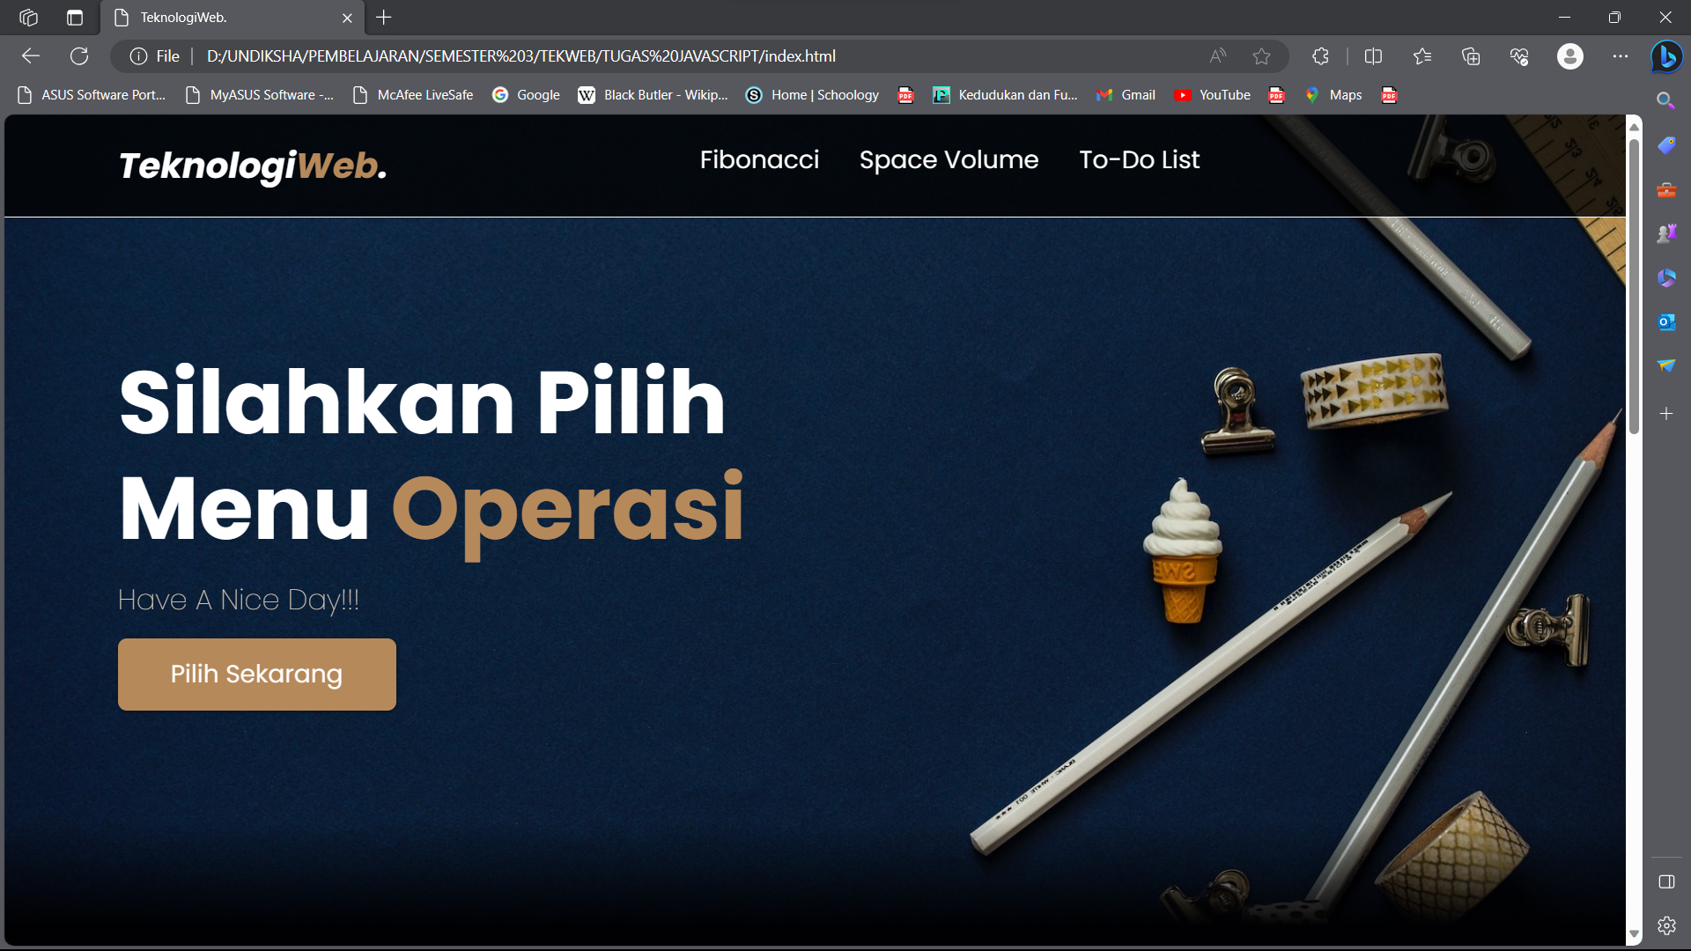

(Image 1. Initial View)

## Fibonacci Web View

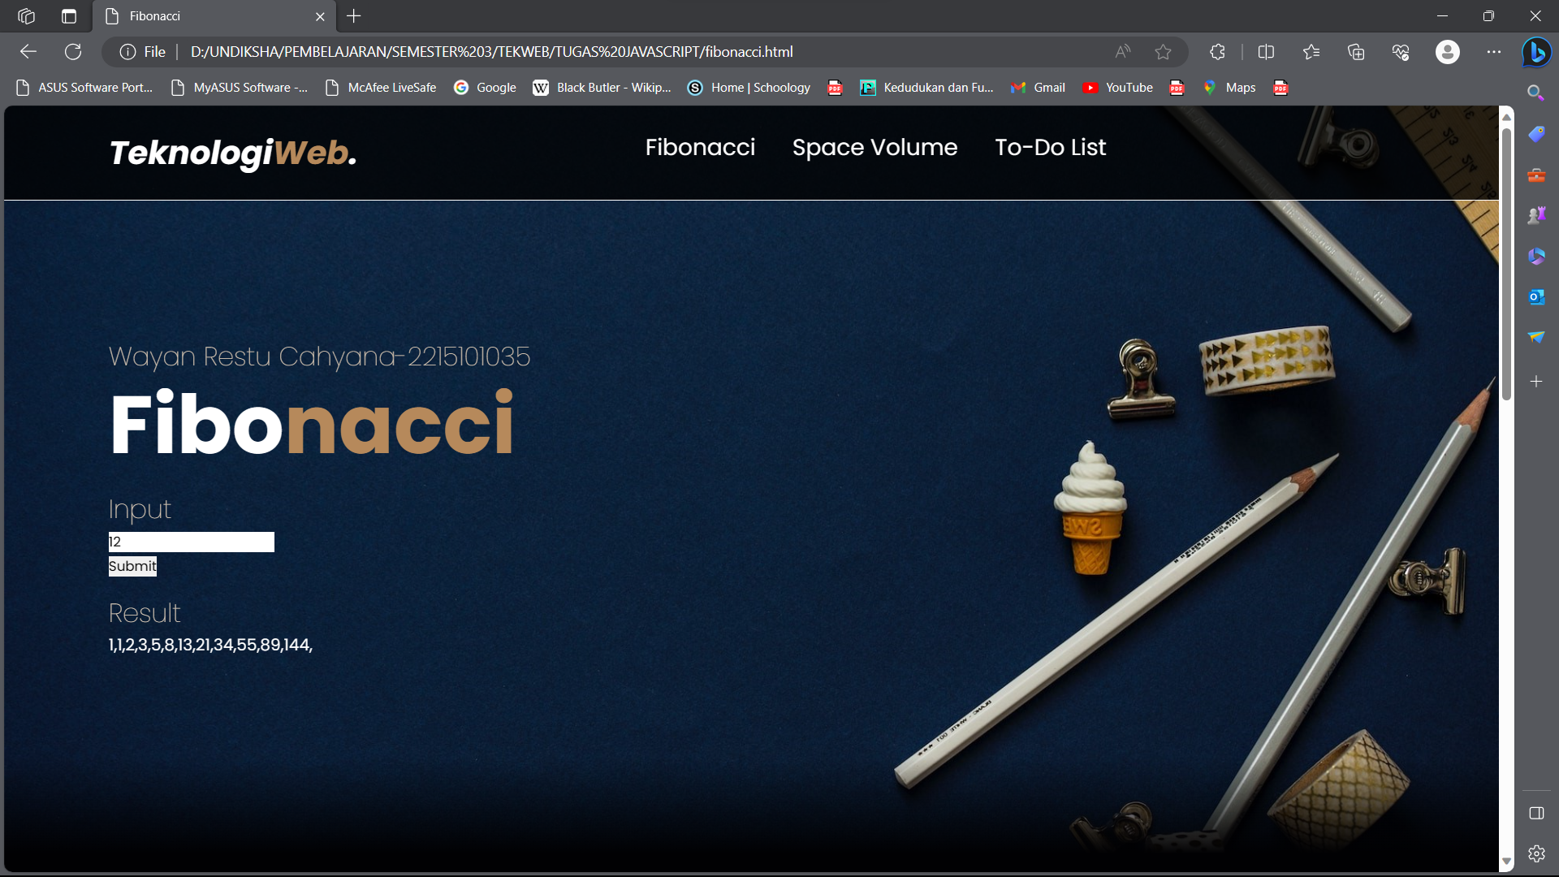

(Image 2. Fibonacci View)

## Compute Volume Web View

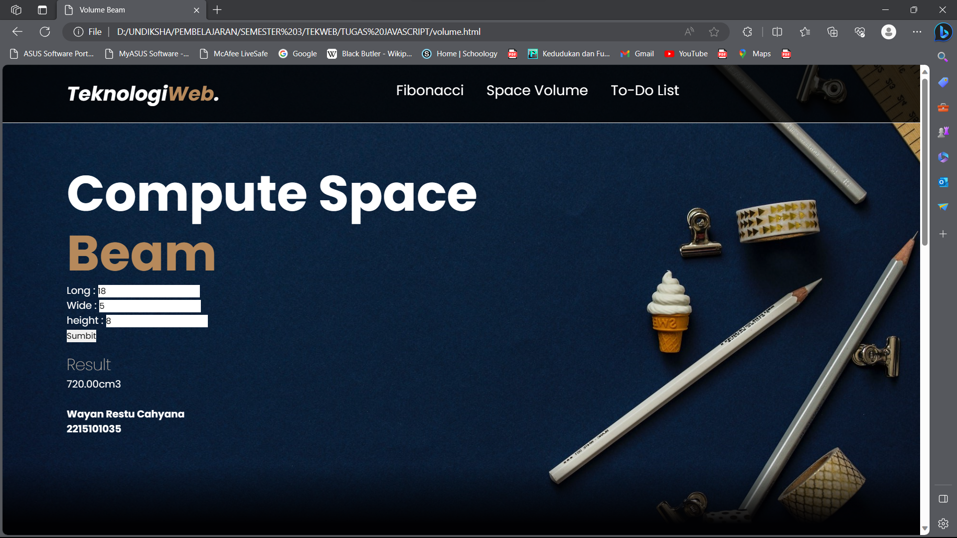

(Image 3. Compute Volume View)

## To-Do List Web View



(Image 4. To-Do List View)

## Source Code

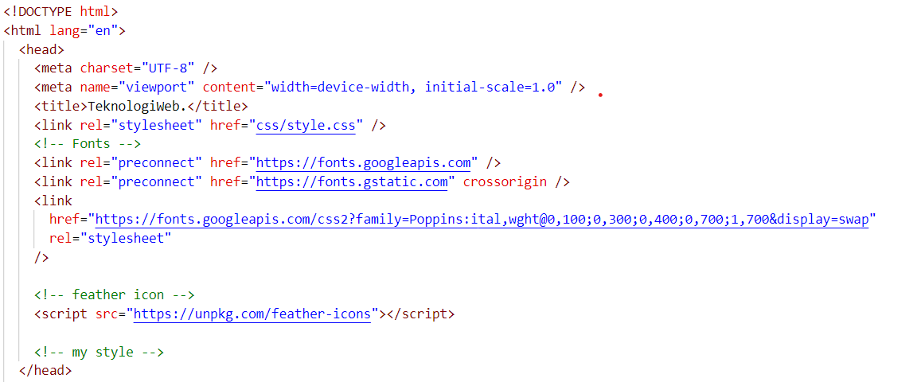

(Image 5. Head)

# **CHAPTER III**

# **CLOSING**

## Conclusion

In every web creation using HTML, CSS is needed as a language to make a website more attractive both in terms of fonts, colors, and appearance. With JavaScript can also make the website more interactive when used by users. This can be seen from the web apps that have been created that are designed with HTML assisted by CSS and JavaScript.